13.81: a) For the center of mass to be at rest, the total momentum must be zero, so the momentum vectors must be of equal magnitude but opposite directions, and the momenta can be represented as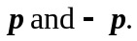

b) 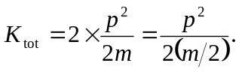

c) The argument of part (a) is valid for any masses. The kinetic energy is

